Drawbacks of using DB Storage as EBS CSI Driver:
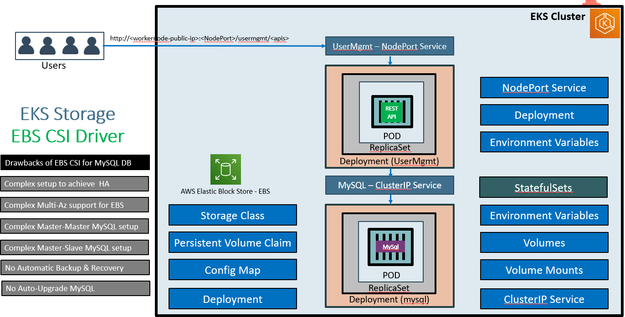
It’s not recommended to use above method in PROD to overcome above drawbacks we use RDS.
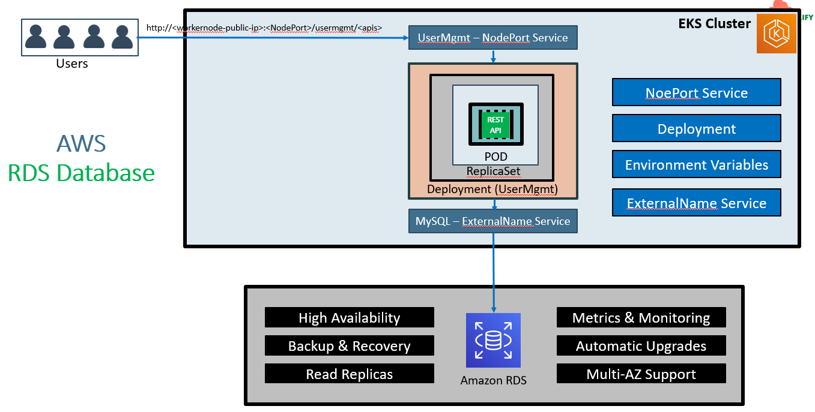
EKS cluster in VPC while using RDS:-
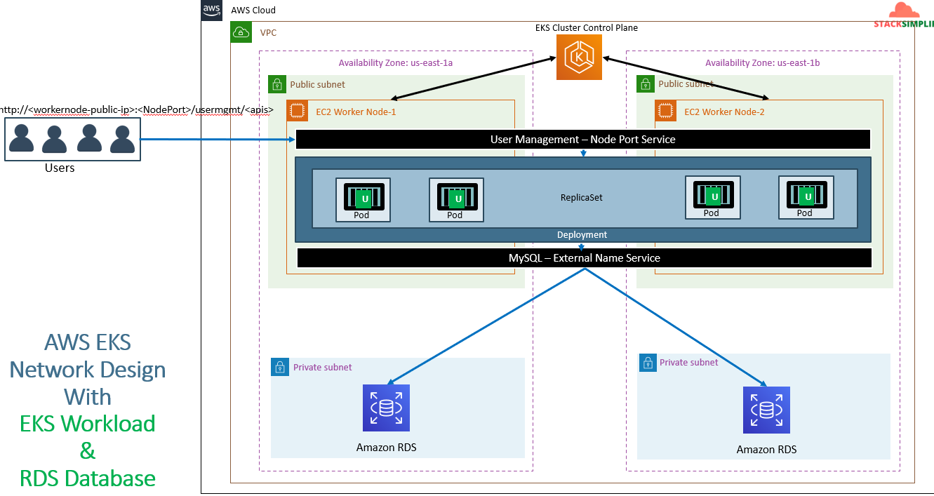
Creation of RDS:-
We are going to create the RDS and attach it to Private subnet of our EKS cluster’s VPC.
As a part of it we are going to create SG with below details.
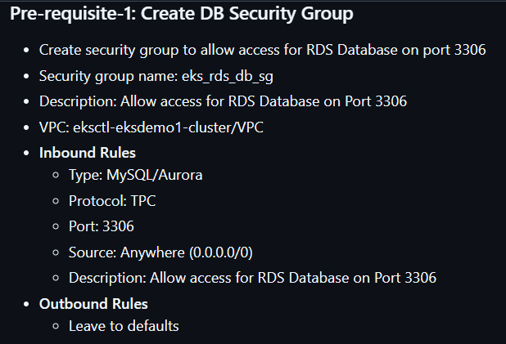
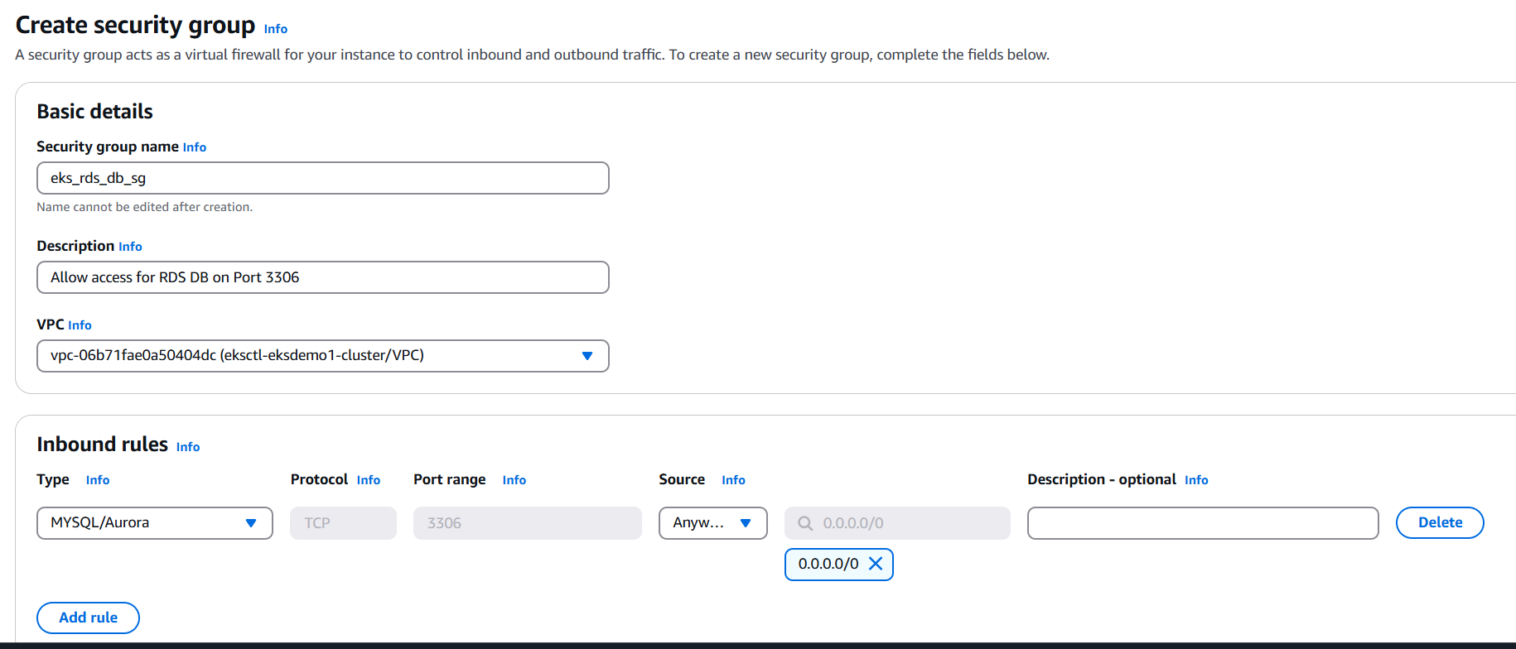
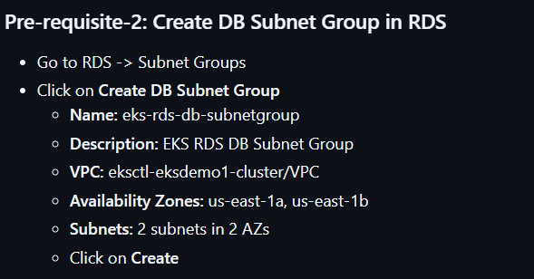
I have created the DB Subnet Group with above mentioned details like below.
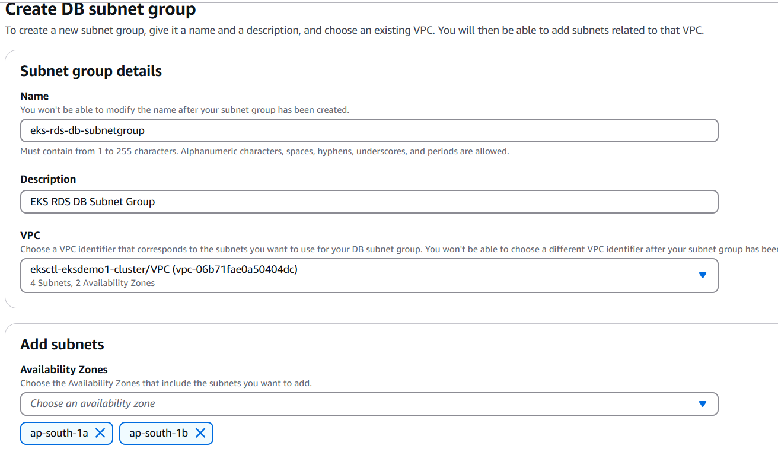
Let’s create RDS DB.
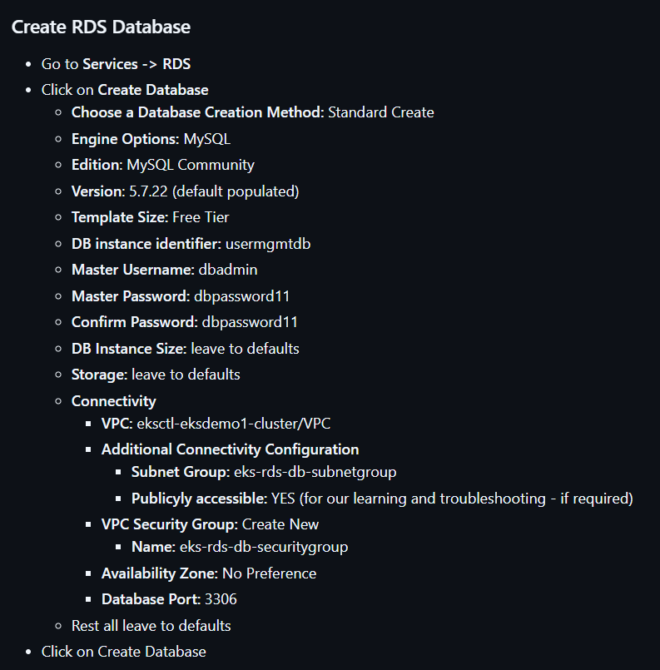
Follow above steps.Reverify the SG.
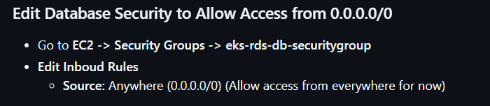
Now create external service
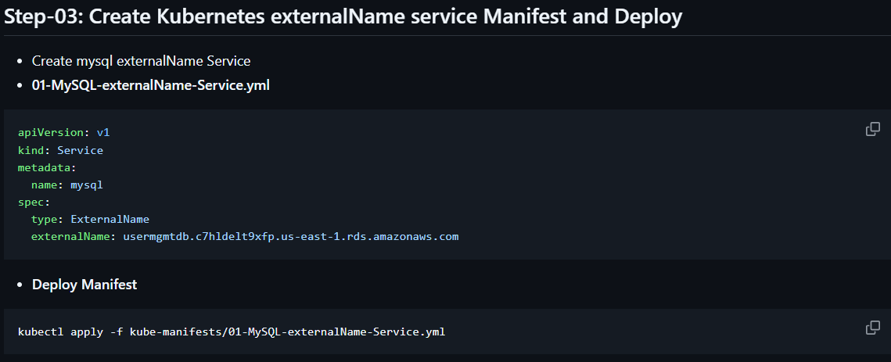
Now connect to the database by running “kubectl run -it --rm --image=mysql:latest --restart=Never mysql-client -- mysql -h usermgmtdb.c7hldelt9xfp.us-east-1.rds.amazonaws.com -u dbadmin -pdbpassword11”
Here “usermgmtdb.c7hldelt9xfp.us-east-1.rds.amazonaws.com” you will get it in from RDS database console.
After connecting run below commands to test.
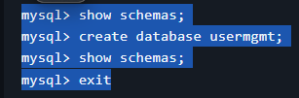
Now copy only Usermanagement application deployment, usermanagement service creation (NodePort service) and secrets file to the external service manifests folder. And give sequence like below.
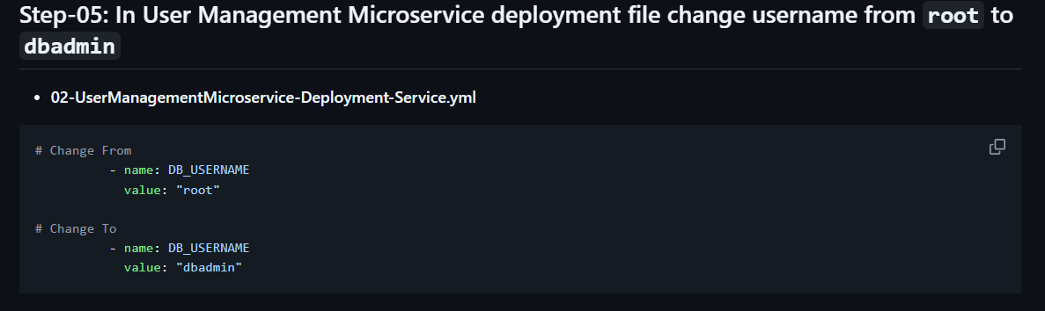
After applying the command again run the “kubectl run -it --rm --image=mysql:latest --restart=Never mysql-client -- mysql -h usermgmtdb.c7hldelt9xfp.us-east-1.rds.amazonaws.com -u dbadmin -pdbpassword11”
- Use usermgmt;
- Show tables;
There u can see the users like below.
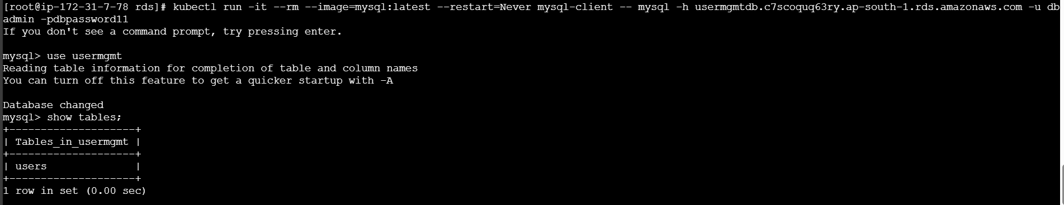
You can verify the usermanagement service in browser also.

